UI functionality

- Go4ItPass.com Landing Page, when user is not logged in
  - Landing page will display following details
    - Screen 1
      - Go4itpass logo
      - Links for user authentication process
        - Signup page
          - Nothing will be mandatory except for user ID and a password
          - If they do not provide an email address they cannot use the forgot password feature
          - Captcha must be solved
          - Note: After signup process user will be asked to login first time and all necessary options will be asked from user.
        - Sign in page
          - Username or email address and password must be provided.
          - Captcha must be solved
          - If user is logged in first time he’ll be asked to fill following options:
            - Make a list to ensure whole configurations.
            - User will be asked to choose usage plan (Basic/Professional)

        - Forgot password page
          - Username or email address should be provided.
          - A mail will be sent to registered email address with a secured URL that redirect user to reset password page.
      - Site title (goforitpass)
      - Aggregate rating with total number of ratings given.
      - Three random comments given as feedback
    - Screen 2
      - Quick information about goforitpass.com that will be as following
        - "The new way to monetize any talent or possessions you’ve got. And to navigate your way through life. Go ad free online; get paid to view ads, or get paid to even advertise depending on how valuable you find your ad to be to the viewer. We also provide merchant accounts with VERY low fee for those who choose not to transfer to another financial institution."
      - Counter with following statistics
        - App / OS Monetization Total Amount
        - Total Wallet Transfer & Withdrawal
        - Total Searcher / Surfer Number of Actions Taken
        - Total Number of Active ads (ads being served right now)
        - Note: All counters should show real-time data.
    - Screen 3 Features
      - Display features about goforitpass.com through icons: 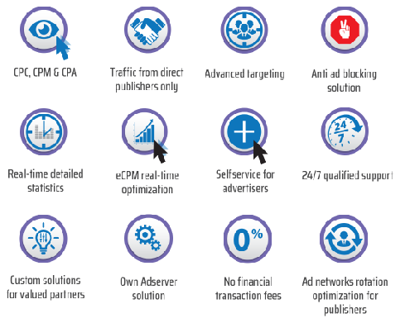
Note: above icons will be modified as following…
        - Icon 1: Choose one or all
          - Cost / Impression (when user views the ad)
          - Cost / Click (when user gets forwarded to the external URL)
          - Cost / Test (when user attends the test)
        - Icon 2: Both publishers and advertisers can set their own price
        - Icon 3: Targeting with the precision of a search engine
        - Icon 4: The most (cost) effective anti-ad blocking solution
        - Icon 5: Real-time detailed statistics
        - Icon 6: Optimize market impact without demanding immediate action
        - Icon 7: Any of the 8 main roles or their subcategories select-able
        - Icon 8: 24/7 qualified support
        - Icon 9/10/11 to be removed.
        - Icon 12: Share both ads & files centrally or peer to peer (for lower cost)
      - Note: Thus, we will have total 9 icons that will be placed 3 per row would be nice.
    - Screen 4
      - Information about things that user can do after being a member.
        - Publishers / Advertisers / Respondents / Merchants / File Sharing
      - A buttons underneath saying the following for all of them.
(alternatively we can have a single button for all of them):
Become Member
    - Screen 5 Available Targeting
      - Information about Available Targeting area through icons
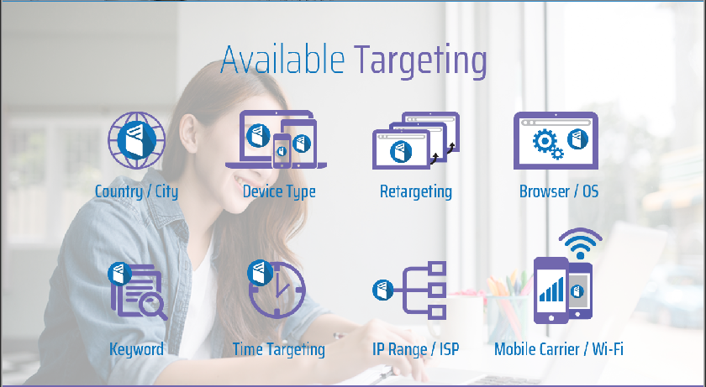
Icons and details will be customised as following…
        - Icon 1: Geo-location as fine as postal code
        - Icon 2: Device Type
        - Icon 3: To be removed.
        - Icon 4: Browser / OS
(For example, Advertisers may want to avoid Linux users or they may want to focus on mac users by identifying browser and OS.)
        - Icon 5: Keyword
        - Icon 6: Local Time Targeting
(like they want their ads to run at the searcher / surfer's local time for example between 5-9 pm)
        - Icon 7: IP Range / ISP (Need to research)
        - Icon 8: To be removed? Since we already covered ISP targeting?
        - Note:
>> Application Targeting should be added (websites, mobiles, tablets and desktops applications as well as OSes) to icons.
    - Screen 6 want to know more or about us
      - Contact information will be provided
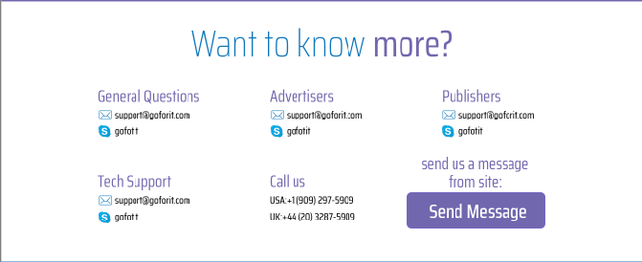
Image will be modified and following details will be shown.
        - General Question (FAQ)
        - Technical Support
        - Call Us
        - Send Mail (Mail will be received by specified email address)
        - Note:
>> Email: support@goforitpass.com
>> Skype/Our chat module: To be decided later
(Owner can set/modify all this details)
    - Footer
      - It’ll contain physical address and other details about goforit.com
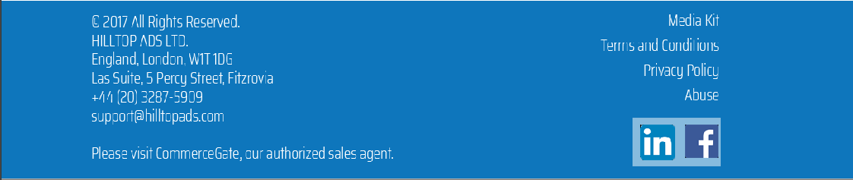
above details will be modified and displayed as following…
        - Address
          - PO Box: 000000000000001
The Republic of Earth
        - Media kit to be removed
        - Terms of Use
        - Privacy Policy
        - Abuse to be removed
(As they should be able to flag the ad for review after each encounter.)
        - Social networking links
(Only Facebook and twitter)
    - Notes:
>> Graphical flow of whole process will be shown to users.
(Need to be designed after whole processes.)
- Go4ItPass.com user will be redirect to specified panel to manage respective task.
  - Home (For Basic and Professional users) with following features.
    - Search Engine
      - Google like search engine tool to search ads and files. Ads will be served to Searcher /surfer/respondent in following way by search engine.
        - Ad/File will be appeared according to the HIGHEST-BID-APPEARING-FIRST or LOWEST-BID-APPEARING-FIRST model that based on pricing scheme
          - HIGHEST-BID-APPEARING-FIRST:
            - Negatively priced ad/file for Advertiser/File-Sharer/Survey-Owner.
            - Competition among advertisers will be for the highest bid
          - LOWEST-BID-APPEARING-FIRST:
            - If it is a positively priced ad/file for Advertiser/File-Sharer/Survey-Owner.
            - Competition among advertisers will be for the lowest bid.
          - RANDOM-APPEARING: Ad/File with PRICE-NEUTRAL scheme will be appeared randomly.
          - Note:
>> By default, Ad/File appearing model will be based on pricing scheme negatively-priced/positively-priced but user can change. LOWEST-BID-APPEARING-FIRST or HIGHEST-BID-APPEARING-FIRST will be automatically applied to ad/file respectively.
>> If 2 ads/files have same bid amount the ads will be displayed randomly at the maximum / minimum bid.
>> If there are only 2 ads/files the ads will be displayed randomly at the maximum / minimum bid.
        - In the case of basic member, with the heading of our site there will be an “Upgrade for Overall Lower Cost” button redirecting to the upgrade details page which will display details of plans for professional membership and option to upgrade plan.
        - Up to 3 ad titles will be appear at a time with following details
          - Title
          - Bid Amount
          - Payment Scheme sign(+/-)
          - Note:
>> In the documentation the names “positive/negative” have been attached based on the advertiser’s earning/loss but in the app itself it will be based on who we are talking to. Essentially here + sign means the respondent is making money and a - sign means the respondent will be pay out of pocket to the advertiser and our fees.
>> Aggregate rating of the ad / file (five star rating system with quarters and halves available)
>> Link to reviews/comments/feedbacks page for the ad/file
        - The respondent can be redirected to any of available subsequent stages on popup with full screen, when respondent clicks on ad title.
          - File Sharing
            - Push
              - Bill will be generated and bid amount will be added for clicking on title. Popup with full screen will be appeared, that will contain respective ad page from our server. At ad page, a “Download” button will be appeared after specified period of time with following details…
                - File Title
                - Bid amount + All fees charged by goforitpass.com respectively
                - Demo file content (Optional)
                - Payment scheme sign(+/-)
                - Aggregate rating of file
                - Download Button
              - When respondent click on download button bill will be updated by adding file downloading amount and Goforitpass.com fees.
              - If user has enough amounts in user’s goforitpass-wallet payable amount will be deducted and receivable amount will be added.
              - After all payments file downloading process will be start.
            - Pull
              - Bill will be generated and bid amount for clicking on title will be added. Popup with full screen will be appeared, that will contain respective ad page from our server. At ad page, a “Post Bid” button will be appeared after specified period of time with following details...
                - Whole details about file wanted
                - A textbox for bid amount
                - A textbox for File Title
                - A textbox for message that can explain about file
                - Button to post bid
              - Note:
>> Other hand file sharer will have a UI, from where he can check all bids and details
>> After checking received bids he can approve one or more bids by sending file uploading request
>> Respondent will receive message/notification about this
>> Message/notification link will redirect him to upload file page
>> When user upload file/give link from his peer a downloading link will be sent to file sharer
>> By clicking that link downloader will be ask to pay bid amount + bandwidth charges. If the user is pro there will be software usage fee too
>> After making payment file will start downloading
          - Questionnaire
            - Push
              - When respondent will click on title bill will be generated and a popup will be appear with following details about questionnaire
                - Questionnaire Title
                - Numbers of questions
                - Details about topic that questions covers
                - Bid amount + goforitpass.com fees
                - Payment scheme sign(+/-)
                - Aggregate rating for current questionnaire
                - Continue button
              - Respondent will click on continue button if he want to continue with questionnaire
              - Before start questionnaire respondent will be asked to pay all fees
              - After paying fees respondent will be allowed to view questions and give answer
              - At the end result will be sent to respondent by message/notification in hardcopy also if available
            - Pull
              - When respondent will click on title of questionnaire demand bill will be generated. And a pop up will be appear with following details.
                - Questionnaire Demand Title
                - Details of topic which is asked for questionnaire.
                - Textbox for bid amount
                - Textbox for title
                - Textbox for details about proposed questionnaire.
                - Button to post bid
              - Questionnaire demander will choose one or more bids
              - If demander has enough money in goforitpass-wallet, he will be allowed to proceed further with selected bid to download content.
              - After goforitpass + questionnaire payment process Questionnaire will be appear
              - Result will be sent to goforitpass.com inbox or other mail box if selected
          - Other
            - If ad contain will be available, bill will be created when user will click on ad title and a popup with full screen will be appeared, that will contain respective ad page from our server. At ad page, a button will be appeared after specified period of time with following details.
              - Title of Website/URL(Optional)
              - Bid Amount
              - Payment Scheme sign(+/-)
              - Aggregate rating of the ad / file (five star rating system with quarters and halves available)
              - Link to reviews/comments/feedbacks page for the ad/file
            - If external Website/URL will be available, bill will be created/updated by adding amount of clicking on website link and redirect user to specified website/URL on same popup with new tab, so that one can go backward to check respective data if needed. At external website page, user will be asked to give a quick multiple choice question test with following details.
              - Thank you message, that asking for taking a quick exam about respective ad.
              - Numbers of questions.
              - Bid amount
              - Bill rejection type selected by advertiser (Whole or this amount only)
              - Payment scheme sign(+/-)
              - Note: User will be allowed to refer previous content of ad as all pages have been loaded in tabs, so that he can pass test successfully.
            - If test will be available, user will be redirected to test page on same popup. If user will pass the test successfully, bill will be created / updated by adding bid amount.
              - In the case of an ad, if user will not pass the test bill will be rejected as per bill rejection option selected by advertiser.
              - In a survey bill amount will be according to the advertiser’s bid.
        - At the end popup will show rating and feedback form to maintain/review quality of content in following ways. (In other words, buyer rates seller in following cases.)
          - In push ads, if the advertiser is unfair in any way they can get negative rating / feedback by respondent.
          - In pull ads the respondent with the winning bid will be rated by advertiser.
        - 3 ad titles will be in scrollable tab that allow user to get next or previous ad titles.
        - After completing 1 cycle of responding to ad both advertiser and searcher/surfer/respondent will be credited and debited respectively unless it’s a neutrally priced ad/file, but even in this case our fees will be payable based on advertiser’s choice and prior knowledge.
        - When wallet of searcher/surfer/respondent have no enough money to view positively priced ad, that user can still view negatively priced ad from available balance and earn money.
        - When advertiser’s wallet has no enough money to pay for advertisement’s bandwidth and in the case of negatively priced ads the bid amount payable to respondent while loading process, advertisement will be stopped being appeared.
      - Basic filters for ads, file searching and questionnaire. (Default selection will be from dashboard and making changes here will be temporary to search differently.)
      - Search engine should load 3 ads of each selected ad type at a time and searcher/surfer needs to use scrolling for next/previous 3 ads.
      - Note: No need to have money in wallet to take money making actions, but to take spending actions they need to have funds in their wallet.
    - Advertisement
      - Ads List (List of ads posted by current user)
      - Post New Ad: Following details should be filled
        - Title
        - Select type of Ad [Push(Sales Ads)/Pull(Want Ads)]
        - Select payment/earning scheme (PRICE-NEGATIVE/PRICE-POSITIVE/PRICE-NEUTRAL) (All sub sequential part will be under same pricing scheme.)
        - Storage Location(Centrally/Peer to Peer)
        - Select type of content
          - File Sharing:
>> File sharing can lead to sales (push ad by uploading of files to the respondent’s machine) and they can also lead to a purchase (pull or want ad by downloading of files from the respondent’s machine)
>> File sharer can share anyone’s file, but if user is not the original copyright owner, user will receive only small portion of the file’s revenue (adjusted by owner) and the rest will be kept in trust till the copyright owner shows up and claims it. [only in the case of positively priced files]
          - Questionnaire
          - Other
        - Upload Content and dependent information based on content type
          - File Sharing
            - Any files
(Software/audio/videos/images/text contents)
            - File sharer have to confirm ownership by selecting one of following options.
              - I am sharing this for a third party copyright owner.
              - I am the original copyright owner of this file. [these choices are for positively priced files only]
          - Questionnaire
            - Question set (Survey/Questionnaire/Certification) Questionnaire will be only in multiple choice questions.
          - Other
            - Marketing Ads
(Images/ text/ audio/videos/online game)
online game can be classified as ads because it’ll be played from browser for marketing purpose.
            - Add External URL (Optional)
            - Set time to activate button for external URL(5 – 60 Sec)
            - Add Multiple Choice Question(s) (Optional)
            - Set time to activate button for Multiple Choice Question (5 – 60 Sec)
            - Select bill rejection method if user fails the test
              - Rejected whole ad’s bill
              - Reject test bill only
        - Add keywords(keywords can have * as wild card character to get maximum search hits)
        - Select Frequency to be searched globally to any user based on budget (Once a Year, Once a Month, Once a Week, Once a Day, Once Every 12 Hours, Once Every 6 Hours, Once an Hour or once every minute) only for PRICE-NEGATIVE scheme because ads which is under PRICE-NEUTRAL and PRICE-POSITIVE schemes are ok to be appeared many times.
        - Select if advertisement should be appeared only once to any user, even after a user id will be edited.
        - Set Bid amount to pay charged/earned from respective user. Bid amount will be differ for ad type push/pull and file sharing/ questionnaire /other.
          - File sharing
            - Push: Bid amount will be the price amount through which user want to sell file.
            - Pull: Bid amount will be received from responder.
          - Questionnaire
            - Push: Bid amount will be the price of questionnaire for sells.
            - Pull: Bid amount will be received from responder.
          - Other
            - Bid amount will be different for every clicks i.e. click on title, click on website link and answering multiple choice question.
          - Note:
>> Advertiser will pay/receive Maximum/Minimum Bid Amount for user + Fees for go4itpass.com
>> In case of nonmember…
            - Temporary wallet will be generated to make money transaction.
            - Temporary wallet will allow user to pay fees
              - Go4itpass.com fees for bandwidth will be automatically deducted
              - publisher’s fee
            - Temp wallet can be accessible after up to 10 years from last use.
            - After that time, the wallet’s remaining balance will be confiscated by goforitpass (remaining amount will be deposited to go4itpass.com) and the wallet will be erased from the database.
        - Note: Advertiser’s go4itpass-wallet should have enough money. In the case of insufficient amount, automated system will ask to deposit money or do something to earn money.
      - Alter Existing Ad
      - Pause / Resume Ad
      - Remove Ad
    - Matching Buyers and Sellers
      - Manual
        - For Sellers (Push)
          - File sharing
            - Receive queries form buyers
            - If file demander will mark approved that will be notified.
            - As the response of approved bid file share will send link for download specified file. File sharer can host to goforitpass.com server or user’s PC.
          - Questionnaire
            - Receive queries form buyers
            - If questionnaire demander will mark approved that will be notified.
            - As the response of approved bid questionnaire owner will send link for view/download specified questionnaire. Questionnaire owner can host to goforitpass.com server or user’s PC.
          - Other
            - Not applicable because we’ve money making scheme by clicking and attending quick exam as per options selected by advertiser
        - For Buyers (Pull)
          - File Sharing
            - Receive bids from respondents(sellers) with following details
              - File Title
              - Bid amount + goforitpass.com fees
              - Details about file
            - Send queries and discuss if needed.
            - Approve one or more request.
            - File demander will receive link to download specified file from approved file sharer.
            - When demander will click on received link, a pop up will be appear with following information.
              - File Title
              - Bid amount + goforitpass.com fees as per demander’s user plan.
              - Continue button for payment process.
            - After successful payment transaction, file downloading will start automatically and a download link will be appeared. In case automatic download process will not be initiated user can use that to download.
            - Same pop up user will be asked to give feedback and rating for that file.
          - Questionnaire
            - Receive bids from respondents(survey owner ) with following details
              - Questionnaire Title
              - Bid amount + goforitpass.com fees
              - Details about questionnaire
            - Send queries and discuss if needed.
            - Approve one or more request.
            - Questionnaire demander will receive link to attempt/download specified questionnaire from approved survey owner.
            - When demander will click on received link, a pop up will be appear with following information.
              - Questionnaire Title
              - Bid amount + goforitpass.com fees as per demander’s user plan.
              - Continue button for payment process.
            - After successful payment transaction, questionnaire will appear. Also a download link will be there if users want to download that content.
            - At the end user will be asked to give feedback and rating for that questionnaire.
          - Other
            - Not applicable because we’ve money making scheme by clicking and attending quick exam as per options selected by advertiser.
      - Automatic
        - For Sellers (Push)
          - File sharing
            - Notification will be arrived when file match found and sales transaction performed by automatic system.
            - Bill amount will be included/deducted as per pricing scheme automatically.
          - Questionnaire
            - Not applicable because questionnaire must be filled manually
          - Other
            - Not applicable because we’ve money making scheme by clicking and attending quick exam as per options selected by advertiser.
        - For Buyers (Pull)
          - File Sharing
            - Notification will be arrived when file found which buyer wanted to buy.
            - Bill amount will be included/deducted as per pricing scheme automatically.
            - Buyer will be asked for feedback and rating for received file.
          - Questionnaire
            - Notification will be arrived when survey will be found for which bids was invited. Link will be appeared to download/view survey.
            - Demander will be asked for feedback and rating for received survey.
          - Other
            - Not applicable because we’ve money making scheme by clicking and attending quick exam as per options selected by advertiser.
        - Note:
>> Automatic match will work only if buyer has enough money in buyer’s goforitpass-wallet.
      - Semiautomatic
        - For Sellers (Push)
          - File sharing
            - Notification will be arrived when buyer will approve suggestion.
            - Receive queries about proposed file.
            - In case of negative pricing for seller, confirmation will be asked. After payment process bill will be generated.
            - Bill will be generated if seller and buyer agreed for transection.
          - Questionnaire
            - Notification will be arrived when buyer send query about survey.
            - In case of negative pricing for survey owner confirmation will be asked. After payment process bill will be generated.
            - Bill will be generated payment will be included/deducted.
          - Other
            - Not applicable because we’ve money making scheme by clicking and attending quick exam as per options selected by advertiser.
        - For Buyers (Pull)
          - File Sharing
            - Notification will be appear when match found.
            - Buyer can ask query if needed.
            - Confirmation request will be sent to seller when agreed with transaction.
            - After confirmed by seller buyer will receive link to download file.
            - When buyer click on download link popup will be appear asking for payment.
            - After successful payment fill will start downloading.
            - Buyer will be asked for feedback and rating for received file.
          - Questionnaire
            - Notification will be arrived when match found
            - Demander can ask queries if needed
            - Demander will send request for survey owner.
            - After confirmation view/download link will be appear
            - When demander click on view/download link, a pop up will be appear for asking payment.
            - After successful payment demander can view or download survey/questionnaire.
            - Demander will be asked for feedback and rating for received survey/questionnaire.
          - Other
            - Not applicable because we’ve money making scheme by clicking and attending quick exam as per options selected by advertiser.
      - Note:
>> Pop up will contain same details with semiautomatic match.
>> Files charges will be deducted on basis on file size or bandwidth needed to connect the peers to each other and start the transfer of file for peer 2 peer transfers. [Only for Goforitpass.com fees]
    - Content Publisher
      - View registered applications
      - Register application where ads will be embedded
        - Application type (web/mobile/desktop/OSes themselves)
          - In case of Web application, enter URL
          - In case of mobile??? Do you have any ideas on how it can be done? Need to research
          - In case of desktop??? Do you have any ideas on how it can be done? Need to research
        - Agreed to terms and condition…
          - To be monetize by go4itpass.com
          - Place ad search engine and a group of intelligently selected ads on following tabbed steps on pop-up as part of our API.
            - Search Engine and 3 ads/file Titles
            - ad content / external URL / multiple choice question (steps will be optional and will be appear if advertiser has placed)
            - feedback / rating as the steps in the case of ads and file download
        - Publisher will earn in return accordingly bill will be generated for publishers.

      - Alter publisher application settings
      - Set targeting algorithms for each app like keywords or specific company or product ads
      - Remove applications
      - On publisher’s application
        - Publisher can host ads/files to publisher’s application(web/mobile/desktop/OSes)
        - Allow us to monetize their app through API
    - External Merchant Dashboard
      - Register application where payment process through go4itpass-wallet will be embedded
        - Add URL to register
        - Develop API in a way that transaction should be done on same page like credit card without leaving website page.

      - View registered applications
      - Alter merchant application settings
      - Remove applications
    - Wallet
      - Summary of 24 hrs.
        - List of Bills
        - Payment Transactions
      - Deposit
      - Withdrawal
      - History
      - Payment Methods (Configure payment processors, local banks and cards)
        - View Configured Payment Methods
        - Choose default currency and payment method
        - Add New Payment Method
        - Edit Existing Payment Method
        - Remove Payment Method
      - Note: The reserve (the goforitpass holding fund currency - this means at any given time the payment processor should convert our holding into Canadian dollars) currency will be Canadian dollars. (If not selected)
    - Dashboard
      - Select Earning scheme (All 3 can be selected at same time.)
        - I want to make money.
        - I am looking for premium content to spend money on.
        - I neither want to make money nor spend money - except for my portion of the cost of running Go4itpass.
      - Check earning statistics
      - Check resource usages
      - Check performance monitoring of ad and file.
        - Number of title views
        - Number of ad/file views
        - Number of external page views
        - Number of attempts of answer question
        - Number of correct answers
      - Choose usage plan.
        - Basic
          - Bandwidth fee for ad/file transfer
        - Professional
          - Bandwidth fee for ad/file transfer as well as other site content data coming from or uploading to our server at/from other site will be counted as other site content.
          - Storage
          - Software usage per…
            - Life Time
            - year
            - Month
            - Week
            - Day
            - Hour
            - Minute
            - Second
      - During registration, the user will be able to choose to go through a wizard which will ask them all the settings of the user including age group, and ad type (one or more of the six – etc.) or whether he chooses the wizard or not he can always visit the dashboard and adjust the settings or they can choose the ad types on the search page's filters
    - Account Settings
      - Edit Profile (Everything should be editable, even the user ID)
      - Change Password
      - Logout
    - Notifications
      - List of all notifications
        - Make a list of notifications
      - Notification should be marked as read/unread
      - Note: Read notifications will only be maintained for pro members so we can levy storage fees. Basic members will get notification alert popup before reading each ad explaining about fees comparison of professional vs. basic member. Nonmember??? They have no account so no notifications whatsoever either.
  - Admin Dashboard with following features.
    - Approve Ads and Files
      - Ads and Files will not be approved in following cases:
        - Files/Ads contains suspicious content
        - Files/Ads with inappropriate titles submitted (i.e. phone number, brand name)
    - Approve Money withdrawal request from users.
    - Other task needs to decide through discussion.
  - Super Admin Dashboard with following features.
    - Create “Admin” user
    - View activities of The Admins
    - Approve Money withdrawal request from users where the total effect to the system is in excess of $20 CAD. (Only for disputes)
    - Need to decide through discussion.
  - Owner Dashboard
    - Create “Super Admin” or “Admin” user
    - Alter user
    - Remove “Super Admin” or “Admin” user
    - File sharer and copyright owner - in a proportion to be set by owner.
    - View activities of The Admins and The Super Admins
    - Set Following Parameters
      - Usage Fee
        - Bandwidth (0.00001 CAD per KB)
        - Storage (size of ad/file)
        - Software usage (life time/per year/per month/day/hour/minute/second)
        - Note:
>> Usage fees will be different for Professional, Basic and Nonmember users.
>> Storage fee will not be applied for nonmember user as they are not storing anything on our server.
>> Basic users do not pay any software usage fee but their bandwidth fee is higher
>> 5 MB Initial storage will be provided to basic user for advertisement storage.
      - Minimum Bid amount for advertise (0 will be price-neutral)
        - Clicking on Ad Title (to view ad)
        - Clicking on website link (to visit external website)
        - Giving quick test successfully
      - Respondent/Surfer ‘s wallet amount limit to give alerts when wallet is near to be empty
      - Bandwidth charge for Peer to Peer file transfer. (owner has to create some plans to be selected by file sharer) This gives me an idea: we can - at the option of the sharer/advertiser- collect bandwidth fee on their behalf.
      - Money will be earned by file sharer and copyright owner if file sharer is not original owner and if the pricing scheme chosen is positively priced.
    - Owner / super admins / admins will be able to make use of the app wallet in two ways each with the limit set by the owner as for the total financial impact on the organization for the second option after some thought I realized the only way to completely separate personal use and organizational use is to mandate two separate accounts:
      - Personal use
      - Organizational use
    - Set/modify contact details (email address for support team, contact numbers and Skype id) to be displayed at footer.
    - Need to decide through discussion.
  - Nonmember
    - On go4itpass.com
      - User will be asked for sign in or signup
    - On publisher’s application and Merchant’s application
      - User will be asked for sign in/signup/temp-wallet that will be managed through cookie
      - Temp-wallet
        - Temp wallet should be kept alive until such time that the cookie on the machine of the nonmember surfer gets deleted or expired.
        - If a cookied machine doesn’t return to the go4itpass app for a period of 10 years the wallet will be destroyed and the balance will be transferred to go4itpass.
        - The pop-up will cover the screen until such time that enough money has been earned to use the (web) app for the way the publisher intended like page load, video or mp3 watching/listening, or using a piece of software for a given period of time or until such time that the nonmember surfer gives up and navigates away from the member publisher’s app.
        - In the case of PRICE-NEGATIVE, payment transaction will be done in following sequence.
          - Advertiser will pay first to nonmember user (respondent/searcher /surfer) in go4itpass-temp-wallet.
          - Go4itpass.com for bandwidth and software usage fees will be automatically deducted from temp wallet.
          - Nonmember user will pay publisher’s fee as he want to get service form publisher.

Notes:
- Header will be on every page that contains Logo and other information(Plan Up-gradation button)
- Surfer can always surf in ad free mode while he has enough money in his go4itpass-wallet to pay. This should be handled as a part of the browsing / software use process where at the exact moment that there are not sufficient funds in the actor’s wallet, he should be asked to either deposit funds or take any of the many money making actions.
- Surfing charges will be deducted from surfer’s wallet until it has enough money. If surfer’s wallet has not enough money, surfer will be notified by automated system and surfer has to deposit money or can earn money through negatively priced ads or other money making actions.
- Feedback and Rating at the end of ad/file sharing
  - Only member can post feedback and rating after login
  - Feedback and Rating can be posted for ads/files/publishers/merchants
  - Our feedback and rating will be published on the main page before login
- Publisher’s Application
  - Publisher’s API will allow us to monetize their app, so that we can put popup with respective content (search engine/ads/files/link to login or signup)
  - When user is not logged in with Go4ItPass.com then user will be asked to login or signup form of Go4ItPass.com.
  - A popup will be appeared on publisher’s site that will allow user to search ads/files and make money by viewing ads/files. The (nonmember) surfer can continue to take money making actions even after he has enough funds to view publisher’s app.
  - Popup will contain pages from go4itpass server (or respective peer) that doesn’t concern with publisher directly.
  - A popup will be appeared asking feedback about publisher when the user closes publisher’s application. (only for members)
- Merchant’s application
  - Money transaction must be done from the same page on merchant’s application through go4itpass-wallet. In the case of physical store money transaction will be done through go4itpass-wallet application for smart phones and tablets.
  - Simple and user-friendly payment process.

